Design a java code which accepts a number(which is non zero and positive ) from the user and then checks if it is a happy number or not. Implement it using nested interface concept

import java.util.Scanner;

public class happyno {

interface NumberChecker {

boolean isHappy(int number);

}

public static void main(String[] args) {

Scanner scanner = new Scanner(System.in);

System.out.print("Enter a number: ");

int number = scanner.nextInt();

NumberChecker checker = new NumberChecker() {

@Override

public boolean isHappy(int number) {

int sum;

int digit;

while (number != 1 && number != 4) {

sum = 0;

while (number > 0) {

digit = number % 10;

sum += digit * digit;

number /= 10;

}

number = sum;

}

return number == 1;

}

};

if (checker.isHappy(number)) {

System.out.println(number + " is a happy number.");

} else {

System.out.println(number + " is not a happy number.");

}

}

}

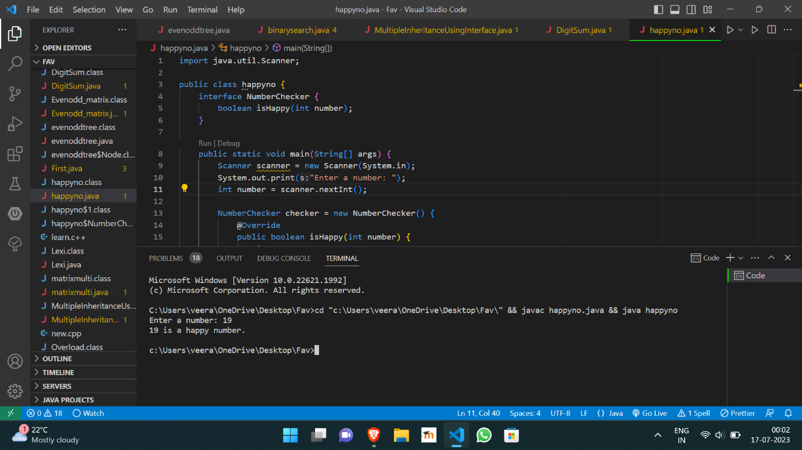

https://github.com/Veeragoutham04/Java_Lab/blob/main/Happy%20number